Name:Adeena Yasin
Subject:Supply Chain Management

Project Introduction:
A data-based dashboard created to analyze supermarket sales performance using KPIs such as total sales, customer ratings, product counts, and sales ratio. This helps in understanding supply chain efficiency and business performance.

DASHBOARD:

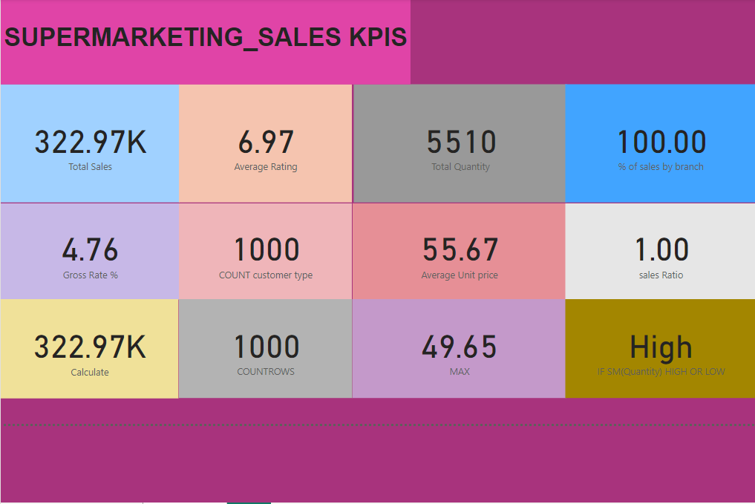

1. Total Sales (322.97K):
- What it means: The total revenue generated from all sales within the analyzed time period. This is a key measure of the overall financial performance of the supermarket.
- Significance: Helps to evaluate the volume of business being conducted and the total monetary value generated.

2. Average Rating (6.97):
- What it means: The average customer satisfaction rating collected from feedback or reviews. This metric is typically on a scale (e.g., 1 to 10).
- Significance: Indicates how well the supermarket meets customer expectations. A higher rating means better satisfaction.

3. Total Quantity (5510):
- What it means: The total number of individual items sold over the analyzed period.
- Significance: Measures the physical volume of sales, which complements financial sales data to provide a holistic view of performance.

4. % of Sales by Branch (100.00):
- What it means: The proportion of total sales that a specific branch contributes. In this case, it’s 100%, suggesting the data reflects one branch only.
- Significance: If data from multiple branches were included, this would compare branch performances, identifying top-performing locations.

5. Gross Rate % (4.76):
- What it means: Gross profit margin expressed as a percentage of sales.
- Significance: Indicates how much profit is earned from sales before deducting operating expenses. Higher percentages mean better profitability.

6. COUNT Customer Type (1000):
- What it means: The total count of unique customer types or classifications, such as Regular, VIP, or new customers.
- Significance: Provides insights into the diversity of the customer base and helps tailor strategies for different groups.

7. Average Unit Price (55.67):
- What it means: The average price of items sold.
- Significance: Useful for analyzing pricing strategy and understanding the overall product mix.

8. Sales Ratio (1.00):
- What it means: A comparison metric that could represent the ratio of actual sales to a benchmark or target.
- Significance: Indicates whether sales targets are being met. A value of 1.00 means the target is exactly achieved.

9. Calculate (322.97K):
- What it means: Likely a duplicated measure of total sales but derived using a calculation formula for validation or testing purposes.
- Significance: Ensures consistency and accuracy in the representation of sales data.

10. COUNTROWS (1000):
- What it means: The total number of rows (or records) in the dataset, typically representing the number of transactions.
- Significance: Indicates the dataset size and transaction volume, which is useful for understanding the scale of operations.

11. MAX (49.65):
- What it means: The maximum value recorded for a specific measure in the dataset. It might represent:
  - The highest transaction value
  - The peak quantity sold in a single sale
  - The highest unit price
- Significance: Identifies standout performance or extreme values in the data.

12. High (IF SM(Quantity) HIGH OR LOW):
- What it means: A conditional measure assessing whether sales quantities are classified as “High” or “Low” based on predefined thresholds.
  - Example: If the total quantity exceeds a specific value, it’s labeled “High.”
- Significance: Helps quickly assess whether performance is within the expected range or surpassing benchmarks.

